Denton Chrysanthemum & Dahlia Society

Annual Sale of
Rooted Chrysanthemum Cuttings
at £1.25 each
Available from mid March onwards

AND

Dahlia Plants
at £1.80 each
Available from May onwards

We have a large selection of all types and varieties to suit your requirements whether it is for Exhibition, Garden Borders or Cut flowers, all at the right price.
For Telephone Orders contact
Ken on 0161 336 6349 or Mobile 07738155114
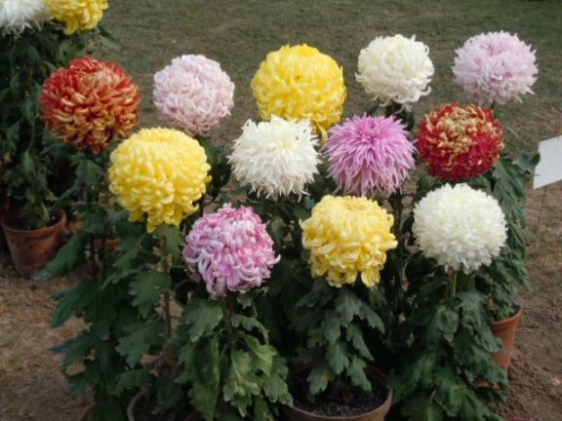
or
Call in to the Show greenhouse at
Wilton Allotments, Wilton Court, off Manchester Road, Denton, M34 2NU
Saturday or Sunday 11am till 1pm.


